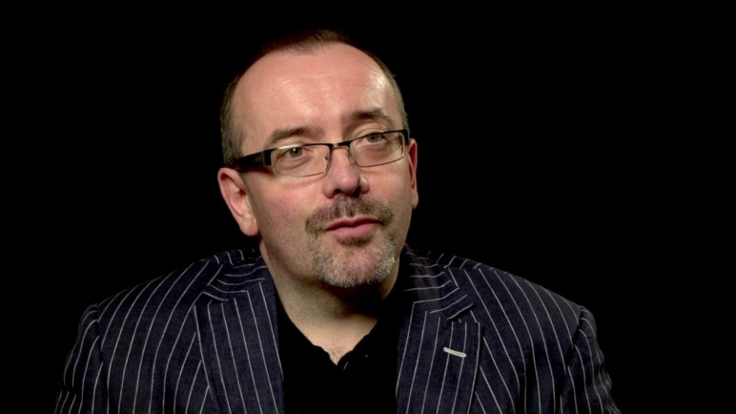
Professor Kieran McEvoy
Kieran is a Professor of Law and Transitional Justice and stepped down in early 2014 as Director of Research at the School of Law, Queens University Belfast. He is a Fellow of the Academy of Social Sciences and was previously employed in the NGO sector before entering academia in 1995. He has been a visiting professor at New York University, Fordham, Berkeley California, Cambridge, London School of Economics and spent a year as a Fulbright Distinguished Scholar in the Human Rights Program at Harvard Law School. He has a long history of human rights and conflict transformation activism. He has served as a board member of the Committee on the Administration of Justice (CAJ) for much of the last two decades, as well as being a founding board member of Community Restorative Justice Ireland. He is also an active member of Healing Through Remembering.
Research Interests
His areas of research interest include transitional justice, truth recovery, amnesties, ex-combatants, victims, human rights, the sociology of the legal profession, penology, restorative justice, comparative legal studies and conflict resolution. He has written or edited six books and over fifty journal articles and scholarly book chapters.
His research has garnered significant international recognition including winning the British Society of Criminology book of the year award, the Socio-legal Studies Association Article of the year award (3 times) - most recently in 2012. In 2008 he was named by Arena magazine as one of the UK’s top ten ‘young intellectuals’ for his work on the Northern Ireland peace process. He has conducted research on transitional justice in Cambodia, Chile, Sierra Leone, Rwanda, Uganda, Israel/Palestine, Colombia, South Africa, Argentina, Uruguay, Spain, Italy as well as Northern Ireland and the Republic. He sits on the editorial board of 6 journals, previously served for 8 years as Review Editor of the British Journal of Criminology and is Series Editor for the Routledge Transitional Justice Series.
While at the Institute for the Study of Conflict Transformation and Social Justice he will be working on two monographs – one on amnesties and conflict transformation (arising from a comparative AHRC funded project which he led - AHE008984 ‘Beyond Legalism: Amnesties, Transition and Conflict Transformation, £305,000) and the other examining the difficulties associated with dealing with the past in Northern Ireland. In addition, he is principal investigator on an ESRC funded comparative project (ES J009849 1 Lawyers in Conflict and Transition, £490,000) and an AHRC follow-on funding project on Amnesties, Prosecutions, the Public Interest and Dealing with the Past in Northern Ireland (AHJO13897 1 £91,482).
Professor Illan Rua Wall
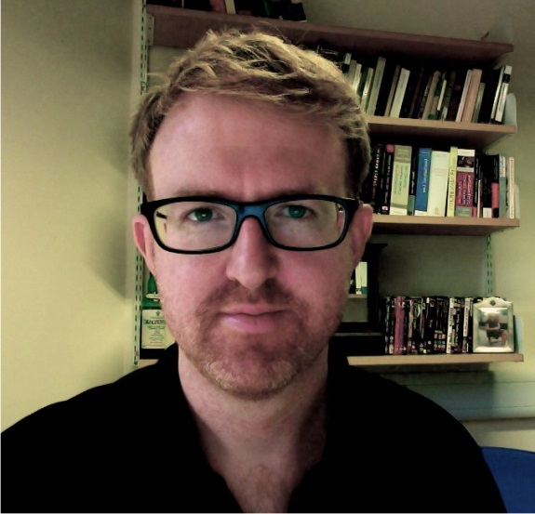
Dr Illan rua Wall is an Associate Professor in the School of Law, University of Warwick. His current research focuses upon the relation between law and disorder. It examines the disorder that makes up the basis of constituent power. Thinking about Occupy, the Indignados and the many current sites of unrest, it begins to develop the novel field of the 'law of disorder'. This is not simply a collection of the various different legal apparatuses that repress or capture disorder, rather the 'law of disorder' thinks about law through and as disorder. He has published on critical legal theory, theories of constituent power, the Arab Spring, protest and transitional justice in Colombia, theories of human rights and revolt, and new Andean constitutional apparatuses.
He is one of the editors of the blog www.criticallegalthinking.com, and is on the editorial board of Law and Critique, and the editorial advisory board of the Journal of Critical Globalization.

Dr Liz Campbell
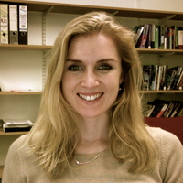
Dr. Liz Campell joined Edinburgh Law School in 2012 as senior lecturer in criminal law and evidence, after being based at the University of Aberdeen since 2007. Before this she carried out doctoral study at University College Cork as a Government of Ireland scholar.
Her principal areas of research are criminal law and justice, with a particular interest in the legal responses to organised crime, DNA databases, and the presumption of innocence.
In 2011, she was awarded a Fulbright fellowship to support her research on the legal reactions to organised crime in the UK and Ireland, and spent 2011-12 at the University of Maryland. Organised Crime and the Law: A Comparative Analysis was published by Hart in February 2013; reviews can be read here, here and here.

Dr. Campbell’s current research projects focus on the definitions of organised crime, and on organised crime and corruption. She is also involved in comparative research with Nessa Lynch of the University of Wellington (NZ) on DNA collection and retention. This project is funded by the Law Foundation of New Zealand.
She frequently provides expert commentary for local and national media, and was a key participant in an RTE documentary on organised crime in Ireland. She contributes to the blog www.humanrights.ie (read contributions here), and tweets at @lizjcampbell.

